Asia-China-Bronze-Shang-Gui-Kuei wg

NK7983.

Period: Shang (18th–12th century bce)

H: x Dia. Vessel: Max. Dia.:

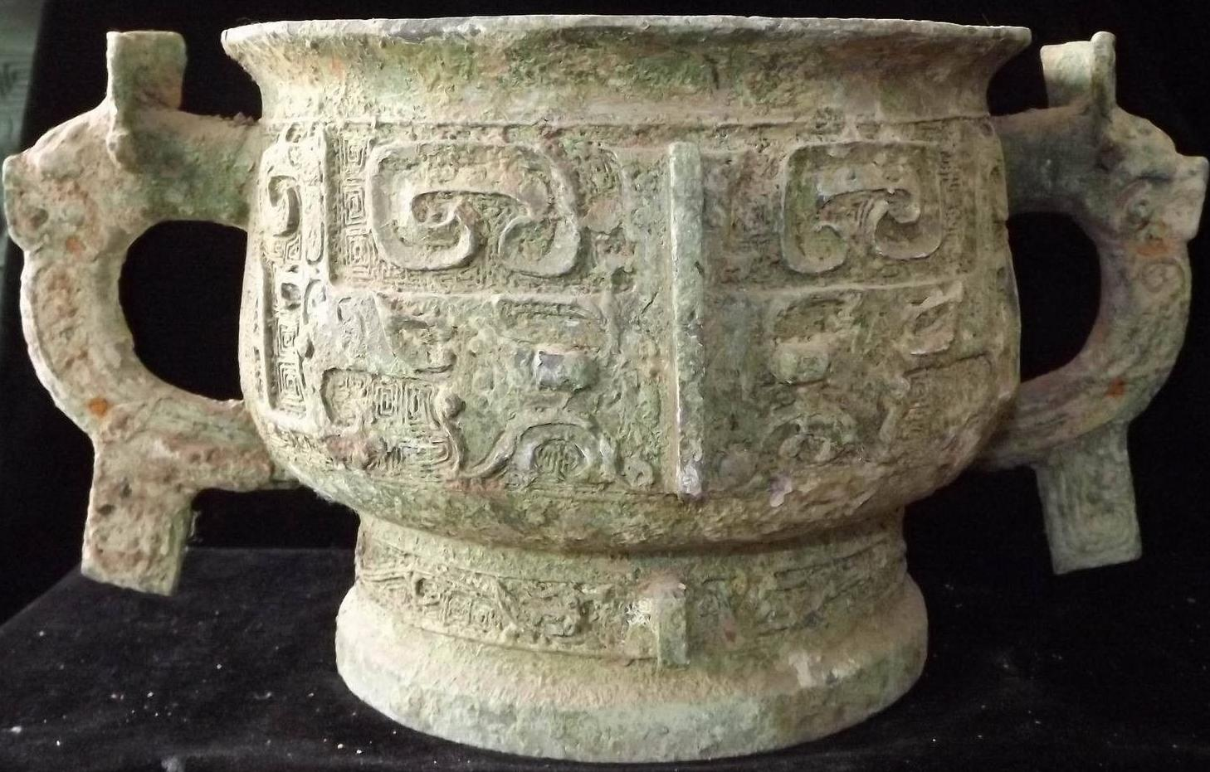

A comparable example is in the Avery Brundage Collection ( d'Argencé 1967:34-35, no. IX).

References:

d'Argencé, René-Yvon Lefebvre. 1967. Bronze vessels of ancient China in the Avery Brundage Collection. San Francisco: Asian Art Museum of San Francisco. [Berkeley, Calif.]: Published by Diablo Press for the De Young Museum Society.

